|  |  |
| --- | --- |
| **NAME :** | S.NIVETHITHA |
| **DEPARTMENT :** | BIOMEDICAL ENGINEERING |
| **COLLEGE :** | DHANALAKSHMI SRINIVASAN INSTITUTE OF TECHNOLOGY |
| **NAAN MUDHALVAN COURSE :** | DIGITAL MARKETING |
| **NAAN MUDHALVAN ID :** | BC6AD3BDAD820A5A79C49EA8333B91D3 |

**ASSIGNMENT ON DIGITAL MARKETING**

1. Create a blog or website using blogspot and wordpress customize the theme design and post new article with 500 words.

Blogspot:[https://bossysss.blogspot.com/2023/08/bags-bossy-is-designed-to-be- subtle.html](https://bossysss.blogspot.com/2023/08/bags-bossy-is-designed-to-be-%20%20%20%20subtle.html)

Wordpress: <https://wordpress.com/home/bossybags.wordpress.com>

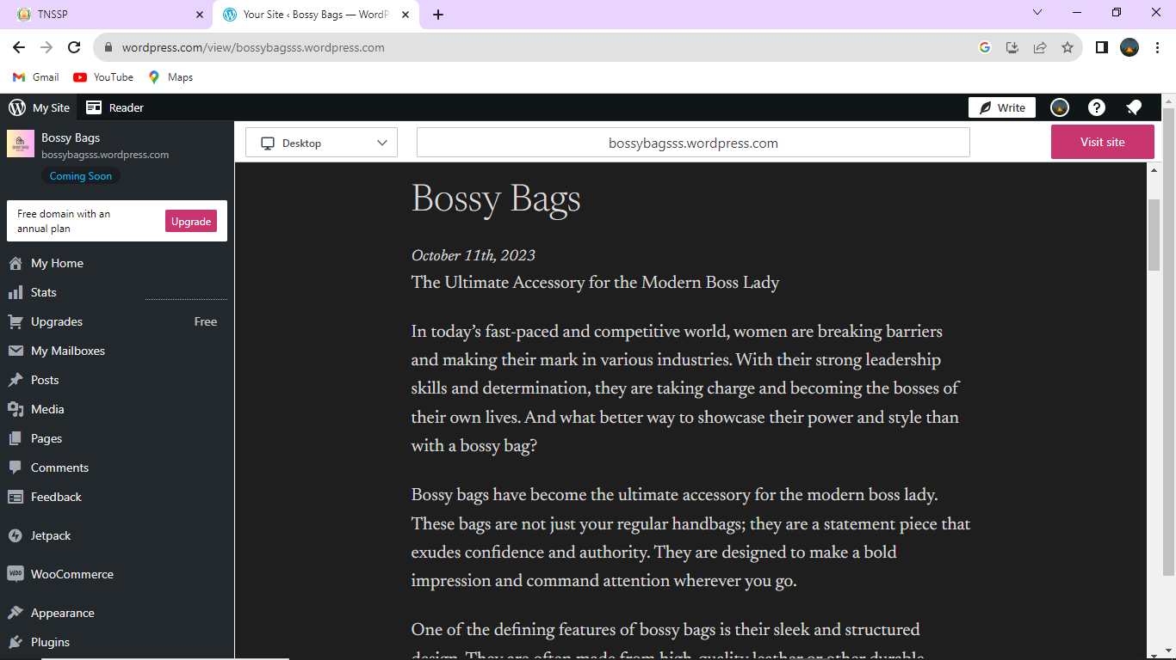

1. Create a new facebook business page and post one social media poster for your brand.

<https://www.facebook.com/bossyssbags>

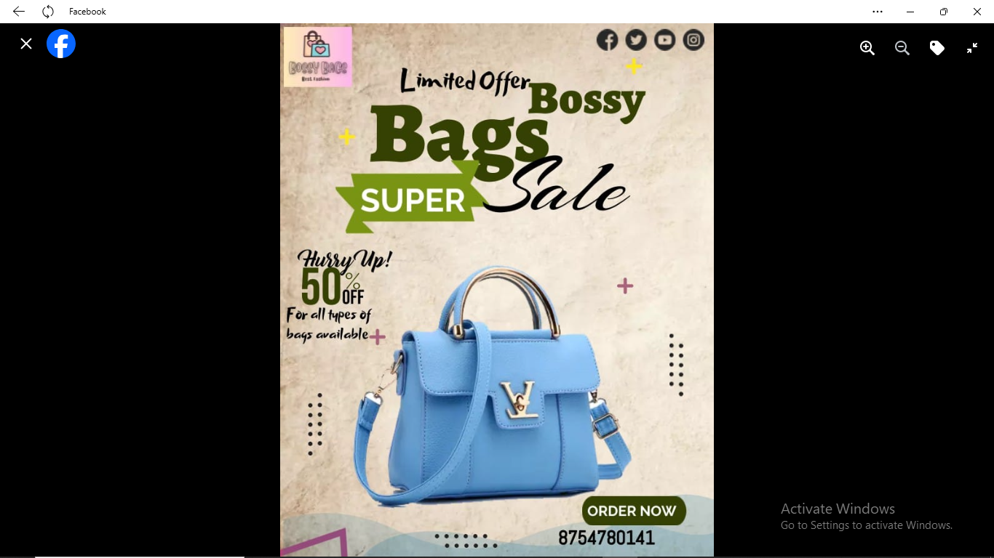

3.Create and design a social media advertisement poster using canva.

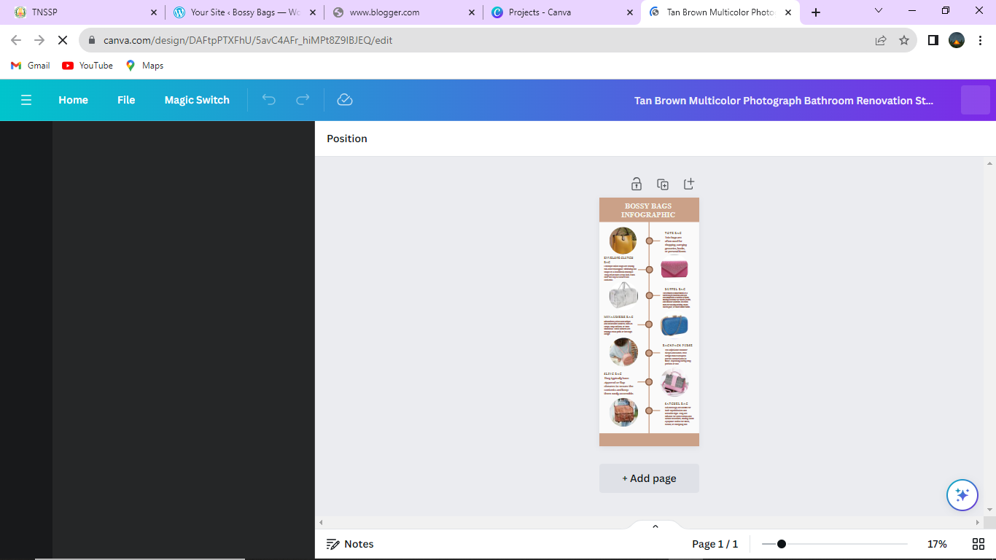

4.Create email newsletter design using Mailchimp or canva tool.

